Experiment 1.2
Variable Transformation between Cartesian, Cylindrical, and Spherical coordinate systems

Code File Name: Exp1_2_Cart2Sph (1).m
Code
clc;
r=input('Enter the value of r=');
phi=input('Enter the value of phi=');
z=input('Enter the value of z=');
% Cylindrical to Cartesian
x=r*cosd(phi);
y=r*sind(phi);
disp('cylindrical to cartesian coordinate system of p(x,y,z)=');
disp([x y z]);
% Cylindrical to Spherical
R=sqrt(r^2+z^2);
theta=acosd(z/R);
disp('cylindrical to spherical coordinate system of s(r,phi,theta)=');
disp([R phi theta]);
Command Prompt
Enter the value of r=10
Enter the value of phi=15
Enter the value of z=20
cylindrical to cartesian coordinate system of p(x,y,z)=
9.6593 2.5882 20.0000
cylindrical to spherical coordinate system of s(r,phi,theta)=
22.3607 15.0000 26.5651
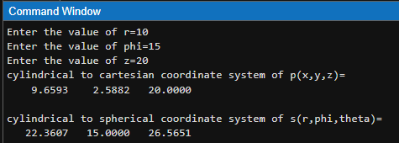
Output Graph / Screenshot

